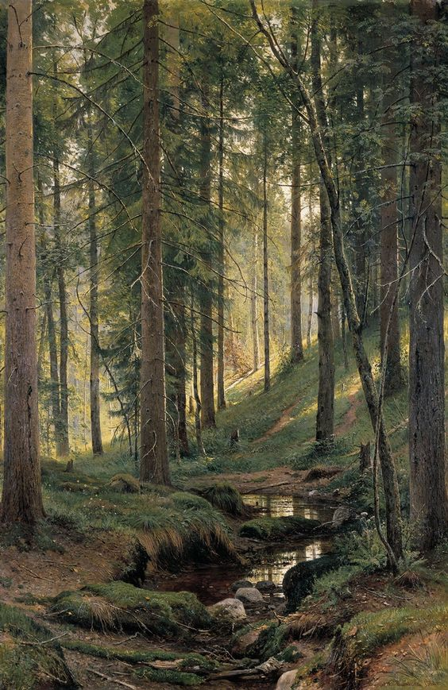

Deforestation

Liquid Galaxy Project

RichardB

# Introduction

Deforestation is the biggest issue of mankind. Each year billions of trees are cut down without looking behind to the empty land that once was called forest. We reached the level of technology to make it happen but decided to spectate the worst that humans can make to themselves.

# Solution

My solution is simple. By using a software that has the principle behind the Liquid Galaxy Project we can teach drones and rovers how to manage the environment and take out the maximum potential.

By placing sensor for terrain scanning on drones and soil quality sensors and drills on rovers we can create a 3D representation of the land. Those sensors will assure that each segment has the potential to guarantee a productive environment for the following planted tree. The software environment will produce images like the following one which will get processed.

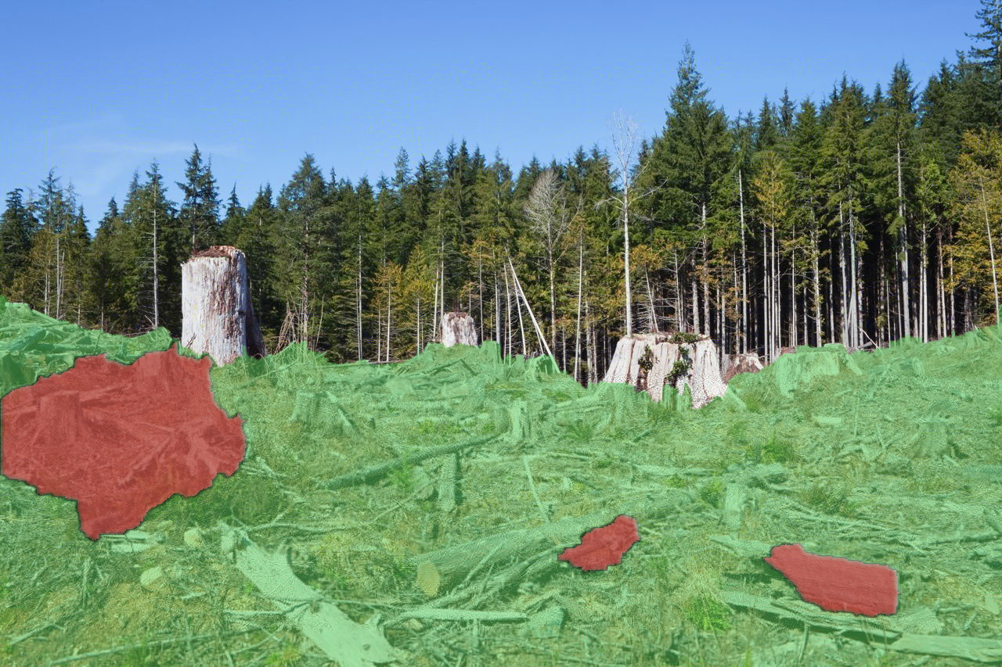

# Description

By using the color-scheme the red segments represent a low potential terrain with lack of soil nutrients and bad topographic placement. On the other hand, the green segment points out to the rover the exact location where a tree must be places to have the necessary needs.

# Steps

Information will be discarded between three devices:

1. Drones;

2. Computer;

3. Rovers;

## 1. DRONES

Drones have the role of scanning the terrain and send the information produced by scanners to the computer. For the proper development of the task, drones must classify in the heavy lifting category. It is recommended to be able to lift more than 10kg of payload and reach an in-air time of more than 15 minutes. My recommendation is the Vulcan UAV Airlift (30kg / 30 min) or the AZ 4K UHD Camera Drone Green Bee 1200 (20kg / 20 min).

## 2. Computer

The computer will permanently run the software that after receiving the data collected by drones will create a 3D environment according to the color-scheme. The program will calculate the area that can be used and will offer each tree an average of 36 m2 (3 meters between each tree trunk). After processing, the coordinates will then be sent to the rover.

## 3. Rovers

Rovers are 6x6 autonomous robots that will be equipped with sensor for soil quality, a camera for recording all their actions (afterwards those will be inspected for improving aspects that went wrong) and a drill that will dig holes for trees and plant the seeds. 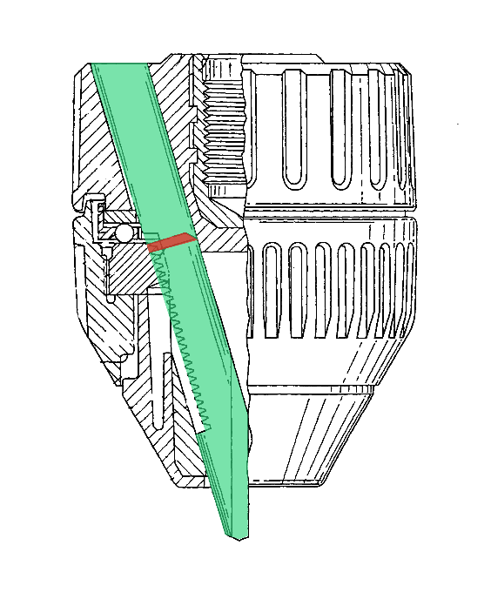

The green segment is the corridor for the tree seeds. After reaching an approximate depth of 60 cm a group of seeds will be spread. During the moving and the digging stages, the red latch will prevent any seeds from falling.

The autonomous aspects of the rover are implemented by distance sensors and gyroscopes. The robot will be able to calculate the distance to an obstacle and avoid it, as well as determining how steep the slope is.

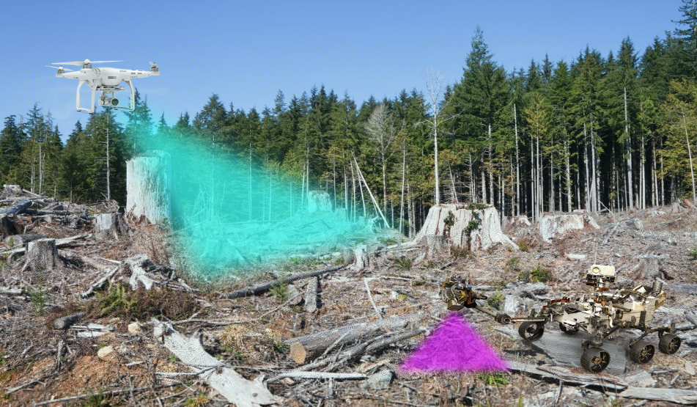 After finishing the route, the rover will return to the starting point and will send to the computer a detailed report which will contain how many holes were dug, which was the quantity of planted seeds, and the success rate.

# Sensors

Sensors used in the process are:

* For proximity we will use the “360 Degree Laser Scanner” (RPLIDAR A2M8). The laser will be placed on the rover and will have the role of keeping the robot far from possible collisions;
* For soil quality inspection the rover will use “Honeywell Force Sensor” (which uses light to measure soil properties; the sensors measure different frequencies of light reflectance in near-infrared, mid-infrared, and polarized light spectrums) and the “Honeywell Force Sensor” (which measures soil compaction or “mechanical resistance.” The sensors use a probe that penetrates the soil and records resistive forces through use of load cells or strain gauges);
* For 3D scanning we can use the “3D Laser Scanner GLS-1500” because of its 500m range, 30.000 points/second scanning speed, 4mm distance accuracy at 150m and remote control via Wireless LAN.
* For the tip of the drill, we will use a depth sensor;
* For detecting the slope, we can place a “PhidgetSpatial” Precision 3/3/3 High Res 3 which is an Axis-Compass, a Gyroscope and an Accelerometer.
* The Night Vision Camera will be the DS-2DF8225IH-AEL(W) with up to 150 m IR distance and 25 x Optical Zoom and 16 x Digital Zoom.

# Conclusion

In conclusion, deforestation is an hard to solve problem because of the tree immense cutting process, but if some smart minds decide to work together, with the right amount of funds, determination and team spirit and we all realize how important nature is and how hard it is to replace what you have been damaging for years, we will manage to reach this objective.

We are close to experiencing a world without forests and should take responsibility for this future if those who destroy every small piece of land refuse to save the planet.